Firewalls

Contents

1. Introduction 2
2. Workflow diagram to deploy the stack 3
3. Create stack for the Firewall 4
4. Plan the Job 8

Introduction

Network firewalls enable policy-based access control for traffic that goes across application/network trust boundaries. Create firewall instances and associate each with a policy that contains the specific rules used to restrict access.Use network firewall and its advanced features together with other Oracle Cloud Infrastructure security services to create a layered network security solution.
A network firewall is a highly available and scalable instance that create in the subnet of your choice. The firewall applies business logic to traffic that is specified in an attached firewall policy. Routing in the VCN is used to direct network traffic to and from the firewall.
This resource provides the Network Firewall resource in Oracle Cloud Infrastructure Network Firewall service. This resource provides the Network Firewall Policy resource in Oracle Cloud Infrastructure Network Firewall service.

Workflow diagram to deploy the stack

Below diagram shows how the Terraform Artifact are applied in the OCI. While creating a ORM stack, using terraform deliverables Init, Plan and Apply is the flow to provision the resource in the OCI. We can have the deliverables in any of below.

- GitLab/GitHub Repo
- Bitbucket
- Can be in folder/.zip in the local disk
- Object Storage Bucket
- Can be in compartment
- Oracle provided Template


Create stack for the Firewall

Go to OCI Console Developer Services Resource Manager Stacks select the compartment Create Stack

My Configuration Folder Browse Select the “oci_network_firewall” folder that contains the terraform Upload

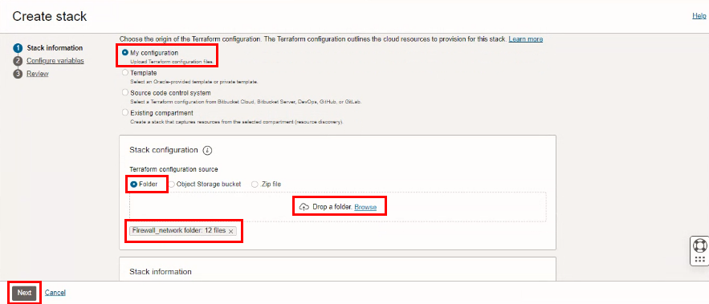

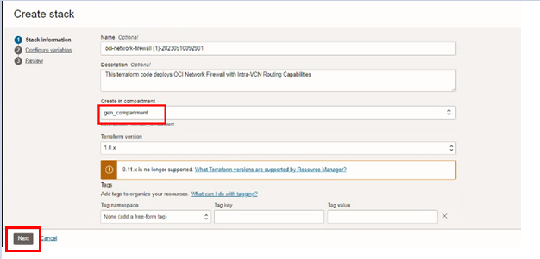

Click “NEXT”
Select the parameters as per the below screen,

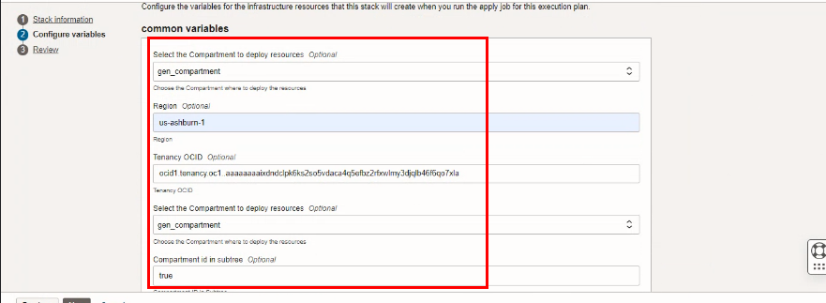

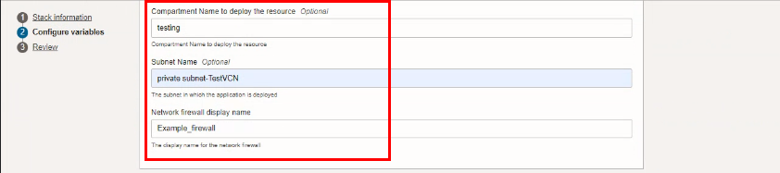

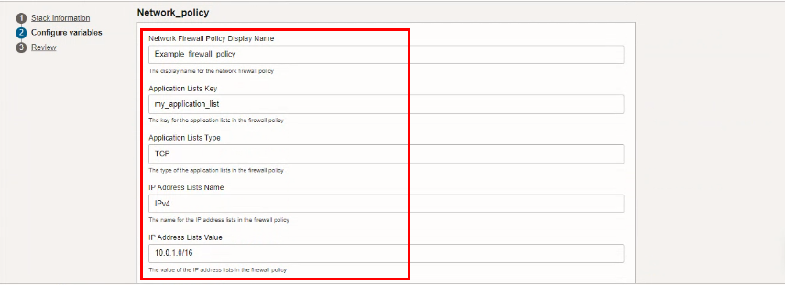

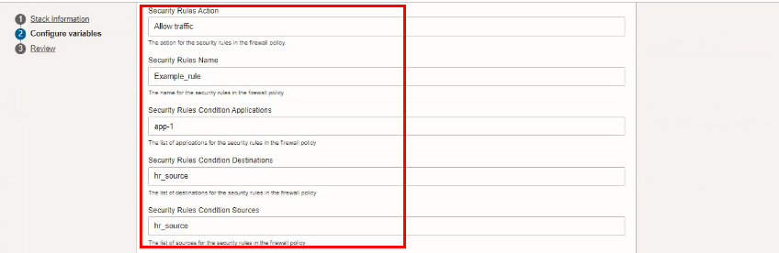

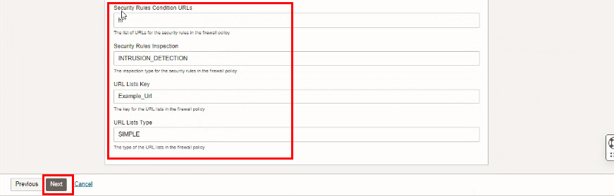
Click “NEXT

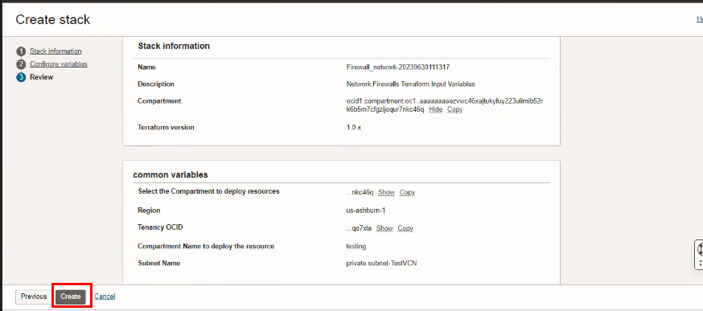
Click “CREATE”

Plan the Job
Click the “Plan”

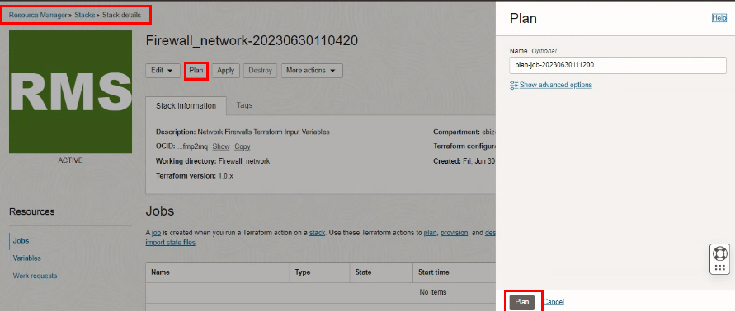

Verify the Plan is successful.

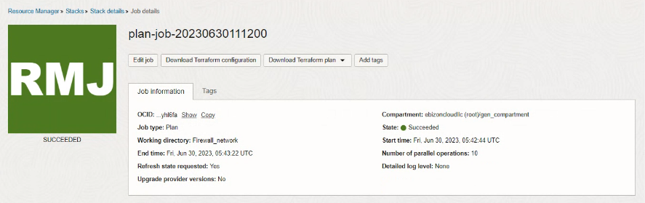

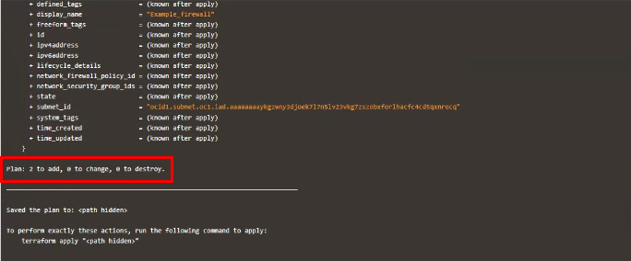

# END #

